- Introduction
  - Structure of Report
This report is organized into multiple chapters, each addressing a specific aspect of quantum light sources with emphasis on weak coherent pulse sources (WCPS) and entangled photon sources based on spontaneous parametric down conversion (SPDC).
This report is designed to provide a systematic progression from fundamental concepts to detailed design considerations, experimental configurations, and current international research trends.

- Introduction
This section introduces a brief overview, objectives and motivation of the report. It provides a structural overview of each section covered in the report.

- Types of quantum light sources
This section is an overview of different types of quantum light sources (WCPS, entangles photon sources and heralded single photon sources). This section builds basic concept for quantum optical sources.

- 810 nm vs 1550 nm laser
Provides a comparison between 810 nm and 1550 nm wavelength. Discusses their suitability for free space and fiber, detection and why are we using 1550 nm.

- WCPS (Section 4-7)
Discusses weak coherent pulse sources. Working principles of WCPS, its photon statistics, key theoretical considerations like second order correlation and Poissonian distribution, design constraints are discussed in this.

- Entangles photon sources (Section 8-12)
These sections explain quantum entanglement, SPDC process, phase matching techniques, and design choices.

- Sagnac interferometer (Section 13)
This section explains what Sagnac interferometer is and its schematics for polarization entangled photon pairs

- Experimental set-ups (Section 14)
Explains various configurations based on PPKTP and PPLN crystals, including schematic descriptions.

- Experimental measurements for Entanglement (Section 15)
Gives numerical data for the previous discussed configurations like coincidence count, visibility

- International Scenario and Latest Trends on Entangled Photon Sources
(Section 16)
Reviews international research scenario, highlighting emerging trends and future directions in this field

Additional sections include abstract, objective, conclusion, bibliography, all intended to aid in navigation.

  - About the Report
This report presents a study of quantum light sources with particular emphasis on entangled photon sources generated through spontaneous parametric down conversion. Quantum light sources have an important role in quantum communication and information processing, where classical light sources fail to meet the nonclassical correlations.

The core objective of this report is to analyze the principles, design considerations, and practical implementation of WCPS and SPDC-based entangled photon sources (mainly for telecom wavelength of 1550 nm). This report explains various phase matching techniques, nonlinear crystal selection and trade-offs of each configuration involved in developing reliable quantum optical sources.

This report not only discusses the theoretical background and technological concepts involved but also provides detailed insights into experimental configurations, measurement techniques for entanglement verification, and real-world considerations for deploying quantum light sources in practical systems. By combining theoretical and experimental perspectives, this report aims to contribute toward the understanding and development of efficient and scalable quantum photonic sources.

- Types of quantum light source
Quantum light sources are essential components in quantum optics because they enable the generation of light which cannot be explained by classic laws of physics. The sources vary as per their application in quantum optics like quantum communication, quantum key distribution (QKD), quantum cryptography and many more. The most commonly used sources as follows:
  - Weak Coherent Sources
Weak coherent sources are obtained by reducing the intensity of a conventional laser so that, on average, less than one photon is present in each light pulse. However, the number of photons emitted in each pulse is random, thus, some pulses may contain no photons while others may contain more than one photon. Because of their simple design, high stability, and ease of implementation, weak coherent sources are widely used in practical quantum communication systems. Their main limitation is the possibility of multi-photon emission, which can reduce security in certain quantum protocols.

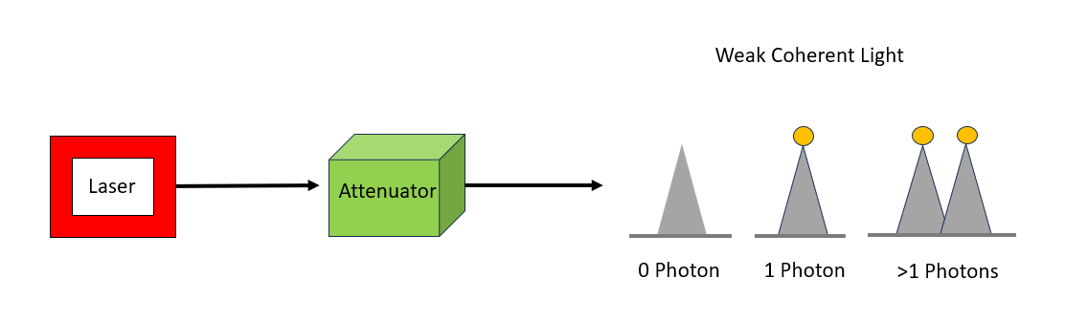

  - Entangled Photon Sources
Entangled photon sources generate pairs of photons that are strongly correlated in their physical properties, such as polarization or time of arrival. Measuring one photon instantly determines the state and properties of its partner, regardless of the distance between them. These photon pairs are commonly produced using nonlinear optical processes like spontaneous parametric down-conversion or four-wave mixing. Entangled photons are crucial for advanced quantum applications, including tests of quantum nonlocality, quantum teleportation, and entanglement-based quantum key distribution.

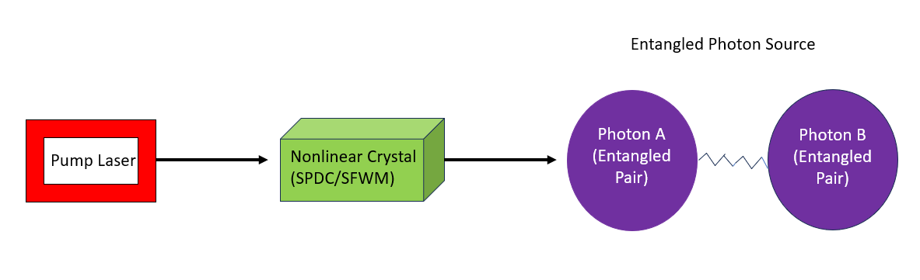

  - Heralded Single-Photon Sources

Heralded single-photon sources work by the principle of producing photon pairs, where the detection of one photon acts as a signal, or “herald,” indicating that the other photon is present. This method allows better control over single-photon generation compared to weak coherent sources. Although the generation is not perfectly deterministic, heralded sources significantly reduce the chances of producing multiple photons at the same time, making them suitable for applications that require high-quality single photons.

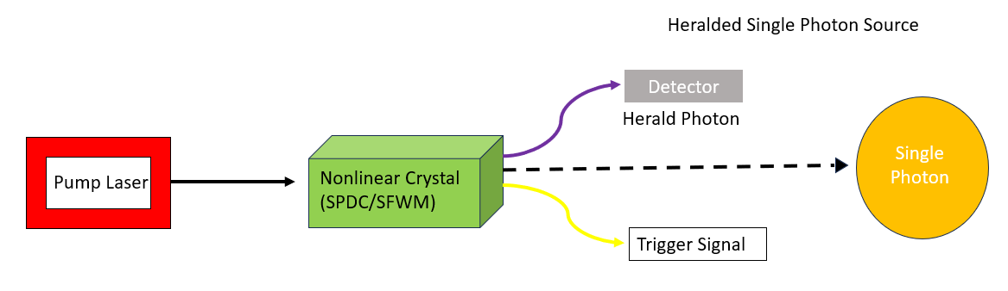

- 810 vs 1550

- WCPS

- Considerations for WCPS

- Design Considerations of WCPS

- General Steps to design WCPS

- Entangled photon source
Quantum entanglement is a phenomenon where two or more particles share a single quantum state, such that the state of each particle cannot be described independently, even when they are separated by large distances.

Example: Consider a photon pair, where one photon is measured as H and other as V. But we do not know which photon is H (or V) without measurement and measuring one photon fixes the state of the other photon.
If photon 1 is H, photon 2 is V, ff photon 1 is V, photon 2 is H.

Entangled photon sources (EPS) are physical systems that generate pairs (or groups) of photons whose quantum states are entangled (in a controlled and repeatable way).
It includes a pump laser, a nonlinear crystal and components to collect, separate and stabilize the photon pairs.

EPS is carried out through a process called as Spontaneous Parametric Down Conversion (SPDC). It splits the laser into signal and idler photons which are entangled.

  - Bell State
A Bell state is a maximally entangled two-qubit quantum state. Bell states represent the strongest possible correlations allowed by quantum mechanics.
A bell state is a standard target states for EPS.
There are four bell states:
$|{Φ⟩}^{+}=\frac{1}{\sqrt{2}}({{\left|H\right\rangle }_{s}\left|H\right\rangle }_{i}+{{\left|V\right\rangle }_{s}\left|V\right\rangle }_{i})$
$|{Φ⟩}^{-}=\frac{1}{\sqrt{2}}({{\left|H\right\rangle }_{s}\left|H\right\rangle }_{i}-{{\left|V\right\rangle }_{s}\left|V\right\rangle }_{i})$
$|{Ψ⟩}^{+}=\frac{1}{\sqrt{2}}({{\left|H\right\rangle }_{s}\left|V\right\rangle }_{i}+{{\left|V\right\rangle }_{s}\left|H\right\rangle }_{i})$
$|{Ψ⟩}^{-}=\frac{1}{\sqrt{2}}({{\left|H\right\rangle }_{s}\left|V\right\rangle }_{i}-{{\left|V\right\rangle }_{s}\left|H\right\rangle }_{i})$
Where s represents signal photons and i represents idler photons obtained from spontaneous parametric down conservation.

  - Bell inequality and EPS Verification
In experiments, correlation alone is not enough to prove entanglement. Classical systems also show correlations, therefore in order to separate classical correlations from quantum entanglement, we need Bell inequality.

Bell inequality is a mathematical limit on the strength of correlations that any classical system can get. When correlations exceed this limit, the particles become entangled.
CHSH Bell inequality is most commonly used in entangled photon sources to prove entanglement. It defines a parameter S, such that:
$S≤2$ for classical systems. If S exceeds 2 them it shows quantum entanglement.
For an ideal Bell state: $S=2√2$. This is maximum possible violation and it shows strong entanglement.

  - Applications of entangled photon sources
EPS is used in Quantum Key Distribution, quantum computing, quantum key teleportation, long distance quantum communications.

Further we will explore how EPS is produced in telecom wavelength (1550 nm)

- Spontaneous Parametric Down Conversion
  - Introduction to SPDC
SPDC is a mechanism for producing entangled photons in nonlinear crystals. SPDC is one the most known techniques used for producing entangled photon pairs because: (1) it is easy to implement and experimentally simple, (2) it works for multiple wavelengths, 810 nm and 1550 nm are some examples, (3) it generates high quality entanglement.
One high energy pump photon enters a nonlinear crystal and it spontaneously splits into two lower energy photons called as Signal and Idler. This happens due to the nonlinear property of the crystal.
This process follows conservation of energy and momentum.
Energy conversion: $ω_{p}= ω_{s}+ ω_{i}$
Pump photon’s energy is exactly split between signal and idler. For degeneracy:${ ω_{s}=ω}_{i}=\frac{ω_{p}}{2}$
Momentum conversion: ${\vec{k}}_{p}= {\vec{k}}_{s}+ {\vec{k}}_{i}$
Can also be written as: $n_{p}ω_{p}=n_{i}ω_{i}+n_{s}ω_{s}$
In nonlinear optics, momentum conservation=phase matching. Phase matching is the condition under which the signal and idler are in phase with the pump wave throughout the crystal, therefore their probability amplitudes add constructively. Without phase matching the SPDC efficiency goes to zero. We use crystals (PPKTP, PPLN, etc) for phase matching.
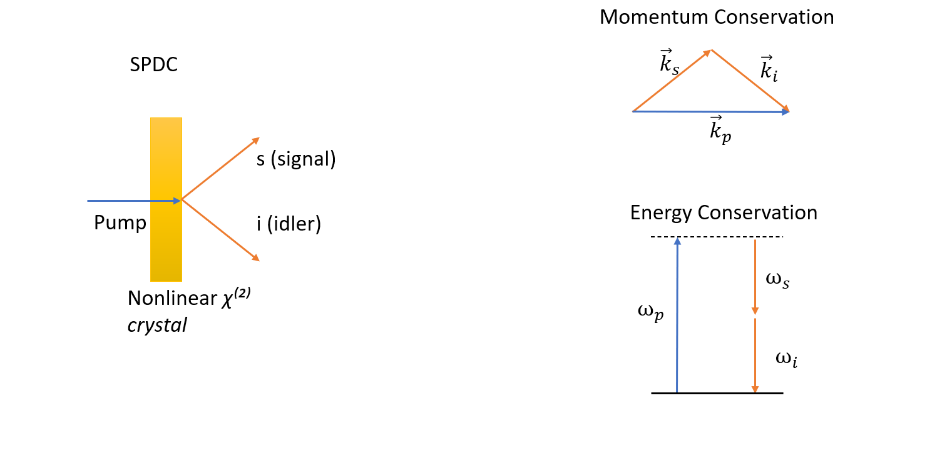

  - Polarization
It is the orientation of the electric field vector of a light wave perpendicular to its direction of propagation.
Ordinary polarization (o): When electric field vector is perpendicular to the plane containing the propagation direction and the crystal’s optic axis.
Extraordinary polarization (e): When electric field vector lies in the plane containing the propagation direction and the crystal’s optic axis.

  - Types of SPDC
    - Based on the polarization relationship of the interacting waves

Type 0: All three photons of pump, signal and idler share the same polarization.
$e→e+e$
Type 1: Signal and idler have same polarization and orthogonal polarization to the pump.
$e→o+o$
Type 2: Signal and idler have orthogonal polarizations.
$e→e+o$

    - Based on the frequency (or wavelength) relationship

Degenerate: Both signal and idler have same wavelength $ω_{s}= ω_{i}=\frac{ω_{p}}{2}$
Non degenerate: Signal and idler have different wavelength $ω_{s}≠ ω_{i}$

    - Base on momentum (wave vector) relationship

Collinear: Signal and idler photons propagate in the same direction as the pump beam.
Non collinear: Signal and idler photons propagate at angles with respect to the pump beam.

- Phase Matching Techniques

Phase matching is a condition in nonlinear processes like SPDC where the interacting waves stay in phase to each other as they propagate through a crystal so that they result in constructive interference.

Phase matching is important in order to satisfy the momentum conservation law. This condition is also called phase matching condition.
$${\vec{k}}_{p}= {\vec{k}}_{s}+ {\vec{k}}_{i}$$
If this condition is not satisfied, a phase mismatch builds up along the crystal, causing destructive interference and strongly reducing photon-pair generation.

  - Perfect Phase Matching
In SPDC:
$${\vec{k}}_{p}= {\vec{k}}_{s}+ {\vec{k}}_{i}$$
But normally $n_{p}≠n_{i}≠n_{s}$, this means that momentum does not balances.
Perfect phase matching is a solution to this.

Perfect phase matching uses the birefringence of nonlinear crystals (such as BBO) to exactly satisfy the momentum conservation condition.
Birefringence is the property of crystal in which light splits into components. Each component experiences different refractive index depending on polarization direction.

Perfect phase matching requires precise angular alignment called critical phase matching. Walk off effects are significant due to birefringence.
  - Quasi Phase Matching (QPM)
Instead of using birefringence, QPM changes the crystal itself (crystals like PPKTP are used). It uses periodic poling for changing the nonlinear properties of crystal.

Quasi-phase matching compensates phase mismatch by periodically reversing the sign of the nonlinear coefficient.
The internal axis of some crystals like PPKTP, PPLN can be reversed, this reversal flips the sign of the nonlinear coefficient $d_{eff}$.

When pump and signal + idler goes out of phase, SPDC output decreases (tending to 0).
When phase mismatch reaches 180°, the crystal domain flips.
$d_{eff}→-d_{eff}$
The crystal is periodically poled with period Λ, flipping the crystal axis every $Λ/2$.
Therefore, destructive interference becomes constructive again.

Poling period(Λ): Spatial period over which the crystal’s nonlinear coefficient reverses its sign for QPM.
The modified phase matching condition becomes:
$$Δk=k_{p}-k_{s}-k_{i}-k_{n}$$

  - Periodic Poling and Quasi Phase Matching
Instead of $Δk=k_{p}-k_{s}-k_{i}$, we periodically pole the crystal so that the crystal axis can
be flipped. This is done by flipping the sign of $d_{eff}$ so destructive interference turns to
constructive interference.
We include an extra grating vector $k_{n}$ such that $k_{n}=2πn​/Λ​$.
The momentum conservation now becomes $Δk=k_{p}-k_{s}-k_{i}-k_{n}$
Where:
For pump: $k_{p}=​2πn_{p}/λ_{p}$
For signal: $k_{s}=​2πn_{s}/λ_{s}$
For idler: $k_{i}=​2πn_{i}/λ_{i}$
And $k_{n}=​2πn/Λ(T)$

- Design considerations for SPDC sources

- Considerations for SPDC for 1550

- Sagnac Interferometer

- Experimental set-ups

- Experimental Measurements for Entanglement

- International Scenario and Latest Trends on Entangled Photon Sources

Conclusion

Biblioigraphy

